

**Youth Shedz**

**Online Digital Safeguarding Policy**

Our Safeguarding Policy covers the overall safeguarding requirements. This Online Digital Safeguarding Policy should be read alongside our Safeguarding Policy and covers the specific requirements for online interaction.

A lot of Youth Shedz activities and interactions are online (or digital). There is no real difference between meeting a young person face to face or meeting them online. There are the same safeguarding risks and the equivalent safeguarding actions and precautions have to be taken to mitigate these risks.

**Responsibilities**

The Youth Shedz Board of Trustees are overall responsible for ensuring that all Youth Shedz activities follow our safeguarding policies.

The Online Safeguarding Coordinator is Scott Jenkinson, General Manager (Mob: 07766 836067).

The Deputy Online Safeguarding Coordinator is Martin Harrison, Chairman, Youth Shedz Board of Trustees. (Mob: 0777 9981230).

**An opportunity to innovate**

Digital technologies present a huge range of opportunities for innovation. Even when we’re not able to physically meet with young people in groups or as individuals, the internet enables us to connect in a range of ways.

Young people who find it difficult to meet and talk in person can often feel much more comfortable communicating behind the ’safety’ of a screen. Connecting through a smartphone or computer opens up huge potential for a different kind of outreach, where we can invite young people to view and even participate in activities without ever having to cross the threshold of a physical meeting space.

|  |  |  |
| --- | --- | --- |
| Reviewed by  Scott Jenkinson | Approved by  Martin Harrison | Date  29 June 2022 |

**Online youth work can take many forms, but these might typically include:**

• Meeting as a group through an online video chat platform

• Connecting with individuals and groups through messaging software

• Broadcasting activities or video on social platforms

• A video call with a young person and two approved youth workers

Each of these methods can provide a great opportunity for youth work which otherwise might not happen, or even for an enhanced experience of what is possible. But all come with risks, which we need to understand and plan for.

**What are the risks?**

It’s important to remember that communicating with young people one to one online, whether via messaging or video, is the equivalent of meeting that young person in a room on your own with no one around.

Communicating with groups and holding virtual gatherings via online platforms also presents challenges that should be considered before giving access to your virtual environment to those who you may not know.

It is also always important to remember that some people do not have access to reliable technology. So when we plan activities that might only be accessible online, we should consider who might inadvertently be left out or isolated by this method.

**Some risks that should be kept in mind include:**

• The opportunity for grooming/sexual exploitation

• Sharing of personal contact details between young people and youth workers

• Inappropriate conversations between young people and workers

• Potential allegations against workers

• Use of apps with minimum age restrictions

• The facilitation of abusive or unkind behaviour (cyber-bullying) between young people

• Particular risks associated with children in care or those known to children's services

**Good practice tips**

As with working one to one with young people in person, there are some ways in which we can still enable safe, innovative work to take place:

**Code of conduct:** We have defined our Youth Shedz Code of Conduct for participating in online groups or interactions, including respectful modes of behaviour and speech, appropriate physical presentation such as clothing, venue, environment, and timings.

**Supervision:** As in normal circumstances, unless unavoidable, contact with young people should take place with appropriately vetted and checked workers present and not by any single worker on their own.

**Record keeping:** Ensure a written record is kept of all one to one video calls held and the content covered in each call. If having assessed the risks of any situation, you believe there is a compelling need to record these calls in place of the usual safer working arrangements, ensure that permission has been sought from the young person (and where necessary, their parent/carer) and the recording is stored securely in line with our usual safeguarding protocols. Where children or young people are either in local authority care or have child protection or children in need plans, additional consents from social workers must be obtained prior to participation in such activities.

**Profiles and devices:** Avoid using personal accounts to enable video chats. Use organisational profiles and devices wherever available.

**Group calls:** To minimise risk, always consider if a group communication can be achieved rather than one to one. Where a one to one video call is required it’s good practice to have an additional colleague in the room with the worker and (dependent on the young person’s age) also better to ask if a parent can be home at the same time. Recordings of group calls should not be made unless there’s a compelling reason to do so.

**Call set-up and admin:** Ensure the call organiser has the ability to mute/block participants in the event they are displaying/sharing anything unsuitable or illegal.

**Age appropriate apps:** Respect the minimum age requirements for video chat enabled platforms and consider a minimum age limit for any one to one chat. Do not invite young people to register for apps, software or platforms which are not age-appropriate for them.

**Reporting mechanisms:** As with online chat groups, having a link to the Child Exploitation & Online Protection Centre (CEOP) or agencies such as Childline, NSPCC etc. ensures that young people can report anything they are concerned about in regards the behaviour of a worker toward them. You should also ensure that parents are aware of who our Safeguarding Coordinator (Scott) is in order to discuss any concerns.

**Regular review:** We will periodically review these arrangements to identify any poor practice or any challenges to positive and safe engagement.

**Additional sources of support:**

**Kidscape** is a national charity providing a wide range of resources and support for those working with young people.

**YoungMinds** is a national charity supporting the mental health of young people.

**ChildNet International** is a non-profit organisation working to help make the internet a safe place for children.

**Click CEOP** is a resource for children and young people worried about online abuse to report concerns.

**ChildLine** is the national helpline for children and young people to talk about concerns (part of the NSPCC).

**Making a connection**

Here is some guidance when thinking about some of the most common forms of online connection with young people:

**Video calls with individuals:** Best practice would be to include two approved workers on a call with an individual young person. If you’re planning to record the call, make sure you have parental consent for this in writing, and are able to store the recording securely (password protected). You should not need to record a call with a young person where two approved adult leaders are present.

**Video calls with groups:** Always ensure you have an appropriate number of approved workers on a group chat, in line with our policy for off-line work. Use an organisational account, rather than a personal account for all calls. Recordings of group calls should not be made unless there is a compelling reason to do so. Wherever possible you should look to password-protect video calls, in order to prevent uninvited people trying to join.

**Interactive online broadcasting:** Make sure that names and personal details of young people are never shared publicly, eg through a live chat function. If you are making your video available publicly, do not share any specific information about young people in what you say. Use an account which is accessible to several members of the team, in case private messages are received. Online broadcasts should not be recorded or stored.

**Use of messaging software:** Always adhere to our safeguarding policy on use of social media and messaging apps. Consider age restrictions for social media apps. Ensure that no communication takes place privately, and that two approved workers are always involved with any messaging correspondence with a young person.

**Expected ways of communicating with young people online**

We do not keep a list of which online platforms have been agreed for use by Youth Shedz as each shed operates independently.

If you have any concerns that the ways of communicating are insecure or are inappropriate, please contact Scott or Martin.

**Virtual Reality**

We maintain a wide range of Virtual Reality (VR) HW and SW capabilities. We need to ensure that these are not being used inappropriately.

**Pictures on the internet**

We publish a lot of reports and articles on the internet about our activities. We need to ensure that we have permission for any pictures and names on the internet, eg website, Facebook etc and that this permission is in writing for anyone under 18 years old and is countersigned by a parent of under 14 years old.

If any young person requests that a picture or reference is removed, we will comply within 2 days.

# **Our Principles and Code of Conduct**

**We have an online Code of Conduct that we expect every Youth Shedder, and people working with the Shedz, to respect at all times they are online**

1. Youth Shedz has a set of Youth Shedz Principles – these must be respected by everyone; the principles are something created by young people for young people, which represents what Youth Shedz stands for:

* We beg, we borrow but we do not steal
* Everybody matters, everybody is valued
* There has to be give and take – it is not a one-way street
* We live for the moment but we plan for tomorrow
* We accept and we are accepted
* We create a safe and secure space where people can turn to
* We leave a legacy for other young people to be a part of
* We serve our community not just ourselves
* We might not have the skills, but we will learn the skills we need
* We eat together, we BE together
* We enjoy the journey together – the highs and the lows

1. Online abuse, violence, bullying, anti-social behaviour and other harmful behaviour is not allowed.
2. Alcohol and drugs are not allowed while online and any person being online showing signs of having taken alcohol or drugs will be asked to leave immediately.
3. Members of the Shed will respect the confidentiality of all individuals, whether present or not – what is said in the online Shed, stays in the Shed (this only changes if we think someone could be in danger in any way).
4. Youth Shedz is for everyone, no matter differences of nationality, disability, age, race, gender or religion.
5. Members will treat everyone online with respect and fairly, regardless of differences of opinions or views – we treat others how we want to be treated.
6. Sheds work best when members work as a team. Every member should take responsibility for helping and supporting each other, whether in person or online.
7. Everyone is responsible for following health and safety rules that are put in place as they are there to keep us safe.
8. If conflict happens, we will help you to reach a resolution that will be to everyone’s benefit. Don’t avoid us or the situation – we are here to help you.
9. No member of the Youth Shedz Staff or team will use their position of power for personal gain or wrongful treatment of others. We respect each other, always.

Any person breaching the online Code of Conduct or ignoring the principles will be asked to leave the Shed and the Trustees will decide as to whether the person will be permitted to return to the Shed. This can include visitors – we expect positive role models of all ages!

**Responding to online concerns**

If you or the young people you’re working with have any concerns it’s important you raise these appropriately. Below is our suggested flowchart for responding. Alternatively, just raise the concerns with Scott or any member of staff or Trustee. Remember to keep the evidence. Don’t delete anything that could be needed for a possible investigation.

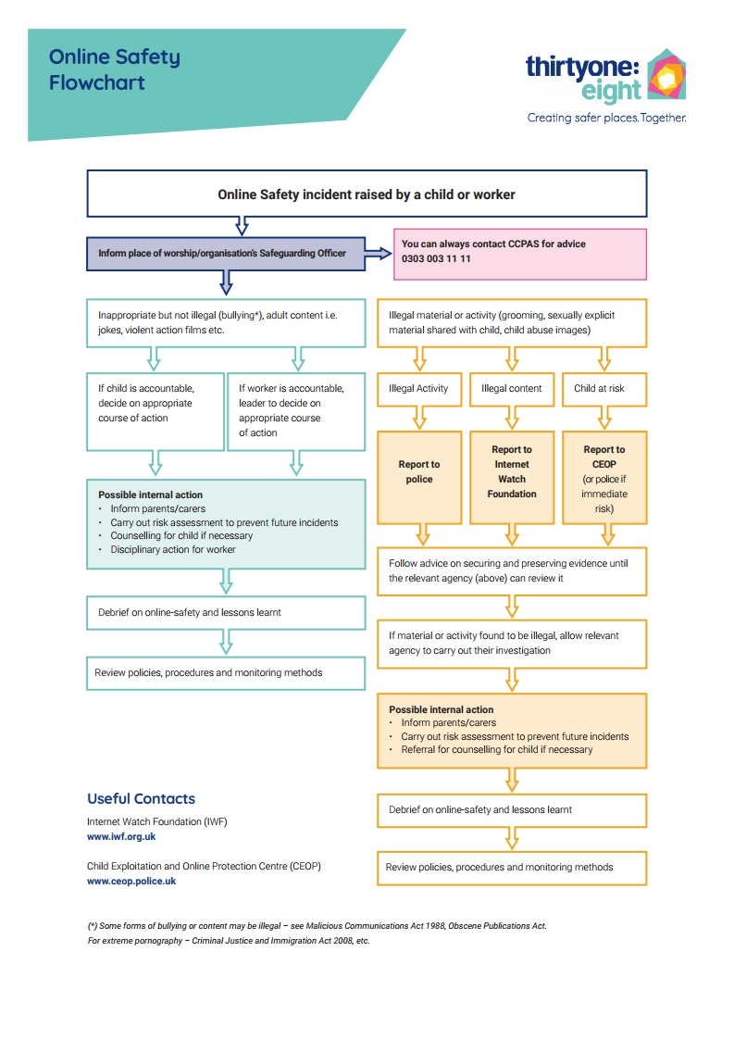

Safeguarding is a

Priority Here

**We are committed to following National and Local guidelines on safeguarding children and vulnerable adults and good working practice, including safe recruitment of workers and volunteers.**

We work to a formal safeguarding policy and it can be seen on request from Youth Shedz Cymru.

If you have any concerns regarding the safety or welfare of a child you can speak to Scott or Sian Jenkinson, or any of our trustees or our staff.

If you have any concerns regarding the safety or welfare of a vulnerable adult you can speak to Scott or Sian Jenkinson, or any of our trustees or our staff.

They have been appointed by Youth Shedz to respond to any safeguarding concerns.



Martin Harrison

Chairman, Youth Shedz Board of Trustees 7 April 2022

**Useful Contacts:**

|  |  |
| --- | --- |
| Thirtyone:Eight 0303 003 1111  Childline ( or children) 0800 1111  NSPCC 0808 800 5000  [Homepage - UK Safer Internet Centre](https://saferinternet.org.uk/) | Action in Elder Abuse 0800 0699 784  Child Internet Safety [www.childnet.com](http://www.childnet.com/)  Internet Safety www.internetmatters.org  CEOP ceop.police.uk  NAPAC 0808 801 0331 |